**CSC 631**

**Homework #2**

**Duy Nguyen**

**917131389**

**2/21/2020**

**Table of contents**

**Cover Page pg.1**

**Table of Contents pg.2**

**Intro pg.3**

**Scope of Work pg.3**

**Implementation pg. 3-5**

**Reflection pg. 5**

**Intro**

For this assignment we were tasked to complete a scene with eight objects that centered around scripting, asset manipulation, and game objects interacting with basic physics. Using the unity engine, we each took on some of the eight tasks mine having been the last two bullet points. They were the instantiation of a game object through button click and using a shader effect when pushing a button.

**Scope of Work**

* Make camera move (i) behind of object as the object moves (like the cube) and (ii) a top down view that looks down the whole scene and switch between (i) and (ii) should be done by key input
* Demonstrate that you can add texture and shading effects on the objects in the scene and change them with button clicks.
* Demonstrate that your objects can respond to collision (and physics properly) and add special effects as a consequence of collision.
* Add particle effects
* A button makes a scene transition (so you should make at least 2 scene)
* A button activates simple character animation
* A button changes shading effect (day to night scene or something else)
* Mouse click picks up an object or creates (instantiates) an object in a scene

**Implementation**

Both aspects of our scene addressed here were relatively easy and required little coding. For the shading effect I used the camera and directional light that comes standard with a new Unity scene. I then added a terrain element that was initially flat but altered to make some rudimentary hills and mountains in front of the camera. I then wrote about five lines of script for the directional light that detected the pushing down of the space bar. When this happened, the script checked if the directional light was on or off and switched it to the opposite state making the space bar a light switch. For the second bullet point I started by creating an in game 3d cube and then made it into a prefab. Then I created an empty game object attached the prefab cube to it and wrote a script. The script again check to see when the right mouse button was clicked and when done the prefab cube would instantiate in front of the camera.

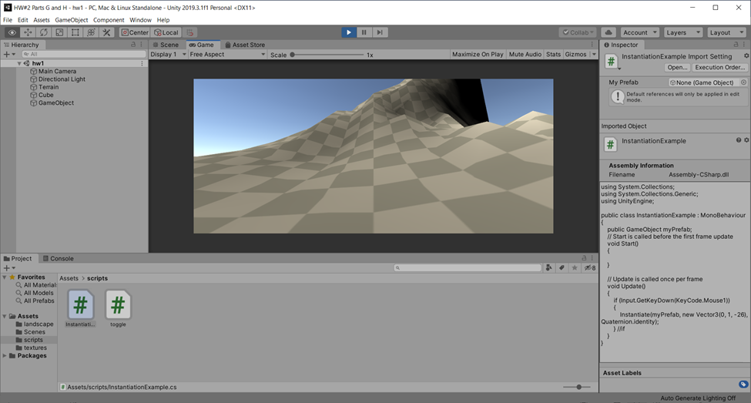

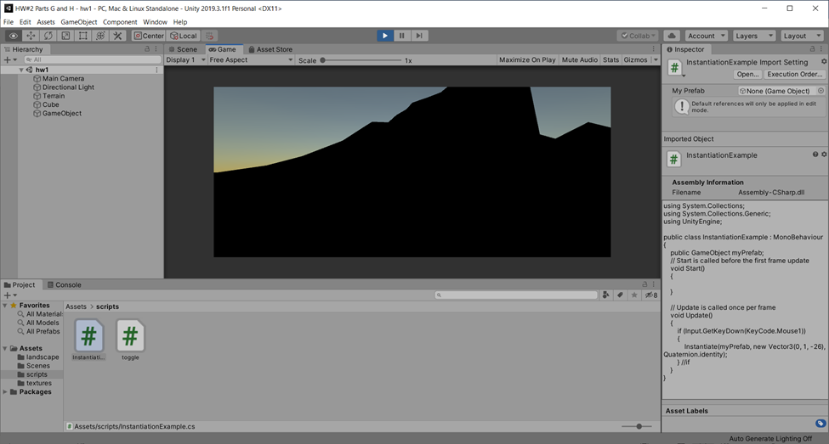

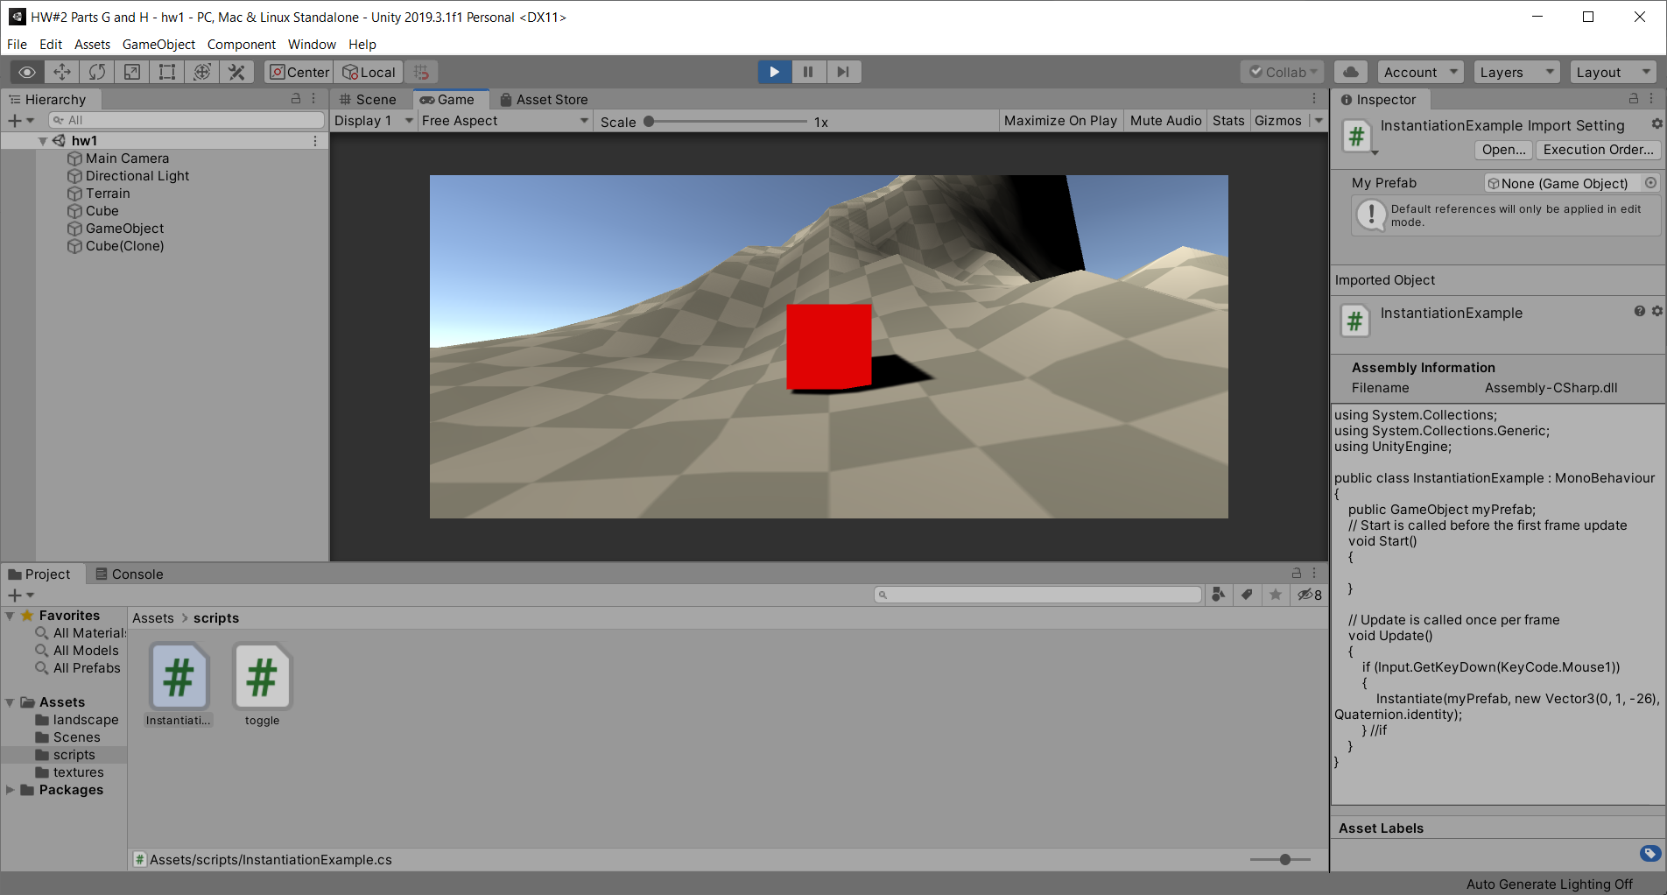

**Reflection**

Overall this project was a great learning experience and great way to dip our toes into the Unity IDE. Learning the UI layout of unity itself was slow at first but after working with it, it became easy to use and read. It really speaks to the forethought and planning that the developers behind Unity put into it and its impressive. The most entertaining and educational component of this assignment was the scripting for the game objects. It was interesting to be able to manipulate in game objects with code as I’d never really understood the process before and what was going on under the hood. In the end this was a great intro to Unity and has made me even more excited for future projects.